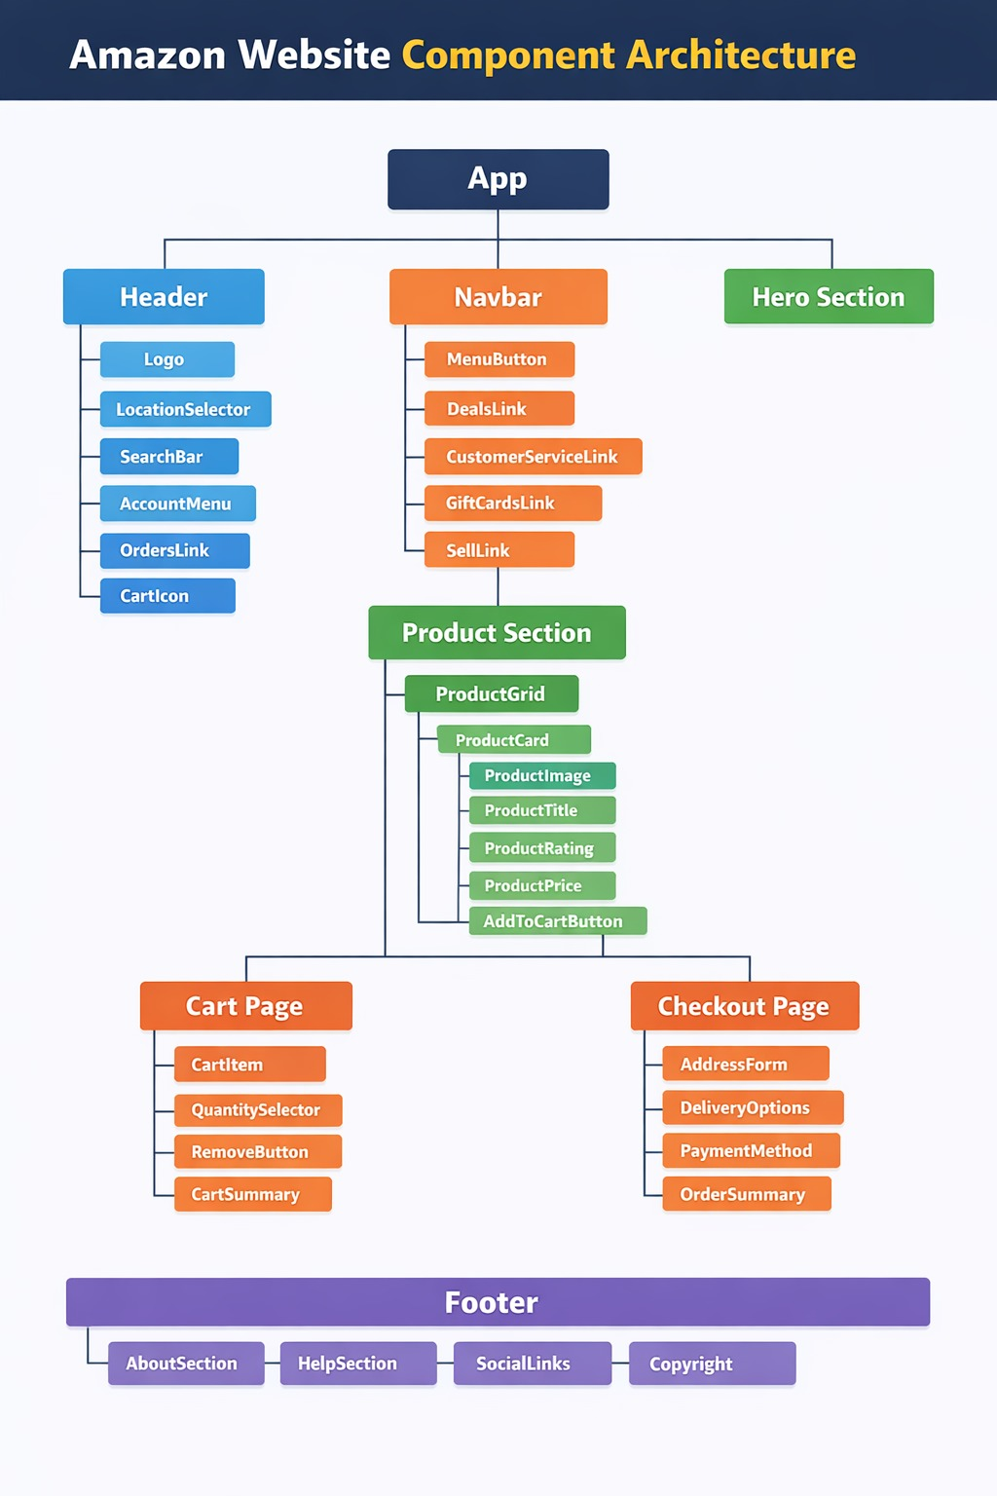
1. App (Root Component)
The App is the main root component of the entire website.
It controls the overall structure and renders the major sections of the application.
Responsibilities:
- Manages global state (user session, cart data, etc.)
- Loads major UI sections
- Controls routing between pages (Home, Cart, Checkout)
The App component contains:
- Header
- Navbar
- Hero Section
- Product Section
- Cart Page
- Checkout Page
- Footer

2. Header
The Header appears at the top of the website and contains important navigation and account-related features.
Components inside Header
1. Logo
- Displays the brand logo.
- Usually links back to the homepage.
2. Location Selector
- Allows users to select delivery location.
- Used to calculate shipping availability and delivery time.
3. Search Bar
- Core functionality of an e-commerce site.
- Allows users to search for products.
4. Account Menu
- User login/signup
- Account settings
- Profile information
5. Orders Link
- Directs users to their order history and tracking.
6. Cart Icon
- Shows items added to the shopping cart.
- Displays cart item count.

3. Navbar (Navigation Bar)
The Navbar provides quick access to important sections of the website.
Components inside Navbar
Menu Button
- Opens product categories menu.
Deals Link
- Shows discounted products or daily deals.
Customer Service Link
- Leads to help center and support.
Gift Cards Link
- Allows users to purchase gift cards.
Sell Link
- Lets sellers register and list products.

4. Hero Section
The Hero Section is the large banner area usually displayed on the homepage.
Purpose:
- Display promotions
- Highlight special deals
- Advertise new products
- Encourage users to explore
It typically includes:
- Promotional banners
- Featured offers
- Seasonal sales

5. Product Section
This section displays the products available for purchase.
Product Grid
- Organizes products in rows and columns.
- Makes browsing easier.
Product Card
Each product in the grid is displayed as a Product Card.
Components inside Product Card:
Product Image
- Shows the image of the product.
Product Title
- Displays the product name.
Product Rating
- Shows customer reviews and star ratings.
Product Price
- Displays the cost of the product.
Add To Cart Button
- Allows users to add the product to their shopping cart.

6. Cart Page
The Cart Page shows all products that the user has added before purchasing.
Components inside Cart Page
Cart Item
- Displays individual product information.
Quantity Selector
- Allows users to increase or decrease quantity.
Remove Button
- Removes item from the cart.
Cart Summary
- Shows:
  - Total price
  - Number of items
  - Taxes or shipping charges

7. Checkout Page
The Checkout Page is where users finalize their purchase.
Components inside Checkout Page
Address Form
- Collects shipping address.
Delivery Options
- Allows users to choose delivery speed (standard, express).
Payment Method
- Users select payment type:
  - Credit/Debit card
  - Net banking
  - Wallet
  - Cash on Delivery
Order Summary
- Final review of:
  - Products
  - Price
  - Delivery charges
  - Total cost

8. Footer
The Footer appears at the bottom of the website and contains informational links.
Components inside Footer
About Section
- Information about the company.
Help Section
- FAQs, customer support, return policies.
Social Links
- Links to social media platforms.
Copyright
- Legal ownership and copyright notice.

Overall Architecture Concept
This architecture follows a component-based design, which means:
- The website is divided into small reusable components.
- Each component handles a specific functionality.
- Components can be reused across multiple pages.
Advantages:
- Easy maintenance
- Better scalability
- Reusable UI components
- Faster development

